Name: Date:

Oprah/Elie Wiesel Interview - Auschwitz Death Camp
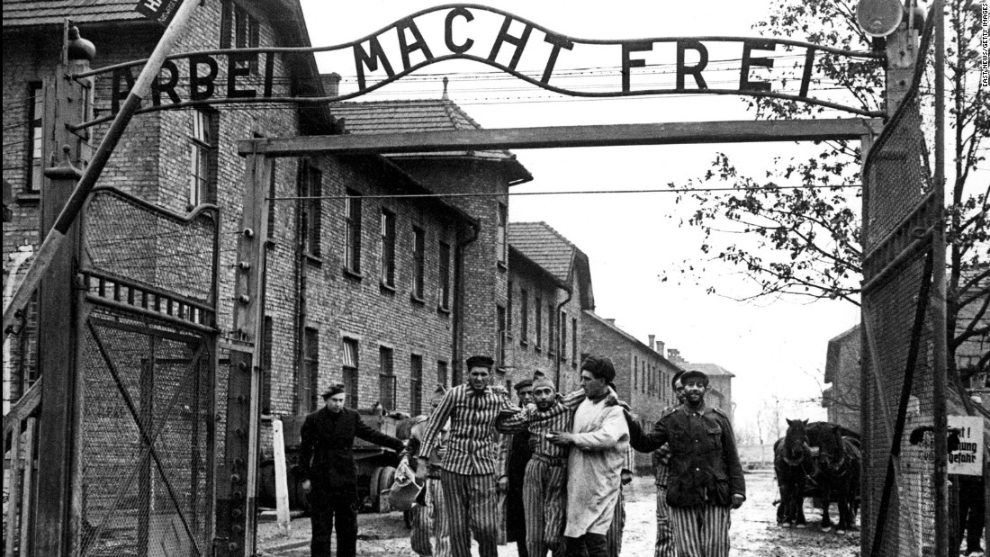

Please answer the questions below as you watch the video. This sheet is due at the completion of the video.

- How many people died at Auschwitz?

- What year did Elie arrive at camp?

- Hitler’s private army is called the ________.

- Auschwitz was larger than ________ football fields.

- What were the 3 parts of Auschwitz called?
1)

2)

3)

“We had no idea what Auschwitz was.”

- Victims were transported to camp in __________ ____.

- The process of ___________________was when doctors and SS officers decided who would live and who would die.

“The mind refused to accept it.”

“There are no words [to describe what he saw].”

“In those times, it was human to be inhuman.”

- _______________(the name of the chemical) was used in the gas chambers to kill many inmates.

  - Fill in the blank: First we were deprived of our ________________, then our citizenship, then our home, then our family, then our name, then our _____________________.

- Allies likely knew about the camps as early as summer of _________ - but camps were not liberated until 1945.

Part II

- _________% of those who arrived at the camp were immediately killed.

Birkenau/Auschwitz II

“We were the exemplary slave, therefore we had to run.”

- In May 1944 - moved to ____________________(what part of the camp?)

“We adjusted not only to madness but to death….We lived inside death.”

“People didn’t cry.”

- Dr. Josef Mengele’s nickname was The Angel of ______________ because of his horrific methods of experimentation.

- Block 11 is famous for the execution wall and interrogation rooms where the _________________ terrorized prisoners.

- Why did people pack suitcases? ________________________________________________________

- One who committed those crimes had no ______________.

19-20. Name at least TWO artifacts that were taken from the prisoners:

21. Your Reactions. In a paragraph (of at least 5 sentences), discuss your reactions to the video.

